**DAILY ONLINE ACTIVITIES SUMMARY**

|  |  |  |  |  |  |  |  |  |
| --- | --- | --- | --- | --- | --- | --- | --- | --- |
| **Date:** | **13/07/2020** | | | | | **Name:** | **NAIPUNYA VINOD NAIK** | |
| **Sem & Sec** | **IV SEM & A SECTION** | | | | | **USN:** | **4AL18CS050** | |
| **Online Test Summary** | | | | | | | | |
| **Subject** | | **MICROCONTROLLER AND EMBEDDED SYSTEMS** | | | | | | |
| **Max. Marks** | | **30** | | **Score** | | | **-------------** | |
| **Certification Course Summary** | | | | | | | | |
| **Course** | **1) GOOGLE CLOUD PLATFORM BIG DATA AND MACHINE LEARNING FUNDAMENTALS** | | | | | | | |
| **Certificate Provider** | | | **COURSERA** | | **Duration** | | | **2 WEEKS** |
| **Coding Challenges** | | | | | | | | |
| **Problem Statement:** Write a Java Program to find the duplicate characters in a string. | | | | | | | | |
| **Status: EXECUTED** | | | | | | | | |
| **Uploaded the report in Github** | | | | | **YES** | | | |
| **If yes Repository name** | | | | | <https://github.com/naipunya-naik/lockdown-coding/blob/master/JAVA%20CODING/Duplicate%20Characters_13-07-2020.java> | | | |
| **Uploaded the report in slack** | | | | | **YES** | | | |

Online Test Details: (Attach the snapshot and briefly write the report for the same).

TODAY MICROCONTROLLER AND EMBEDDED SYSTEMS DESCRIPTIVE TEST-1 WAS CONDUCTED ON 13TH JULY 2020.

* SUBJECT:- MICROCONTROLLER AND EMBEDDED SYSTEMS
* CONDUCTED BY:- MR.VASUDEV S SHAHAPUR
* FROM 9.34 AM TO 10:30AM
* DURATION:- 56 MINS
* NO.OF QUESTIONS:- 4
* TOTAL MARKS:- 30
* MARKS WILL BE PROVIDED SOON
* DUE TO SLOW INTERNET, MY DOCUMENT GOT UPLOADED AT 10.32AM , SO IT TURNED IN LATE.
* 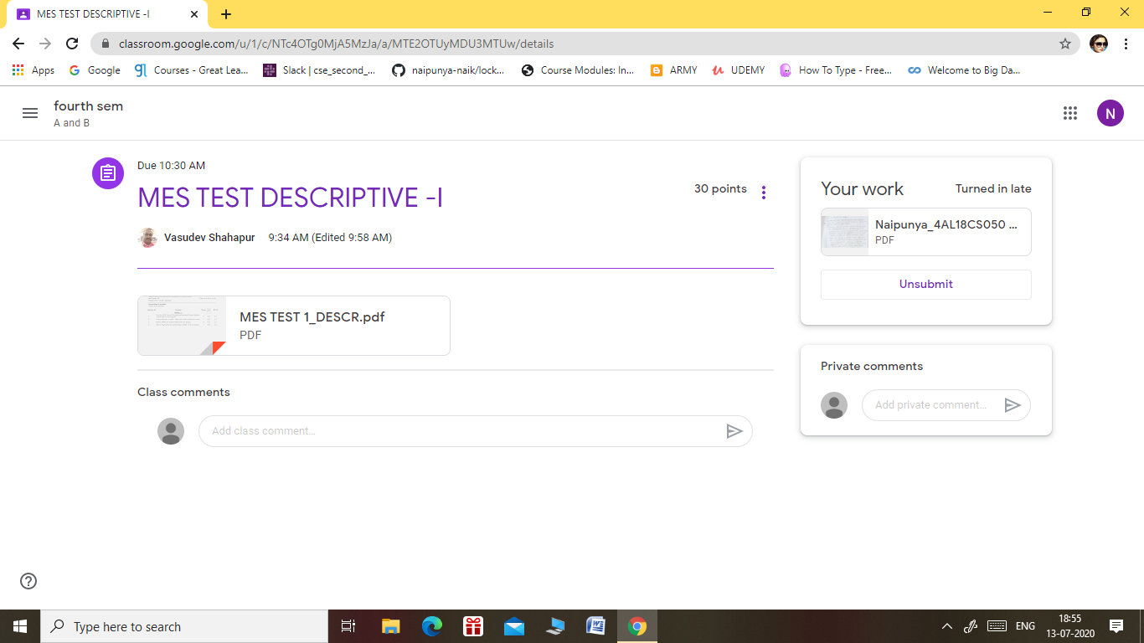

Certification Course Details: (Attach the snapshot and briefly write the report for the same).

CERTIFICATION COURSE NAME:- **GOOGLE CLOUD PLATFORM BIG DATA AND MACHINE LEARNING FUNDAMENTALS.**

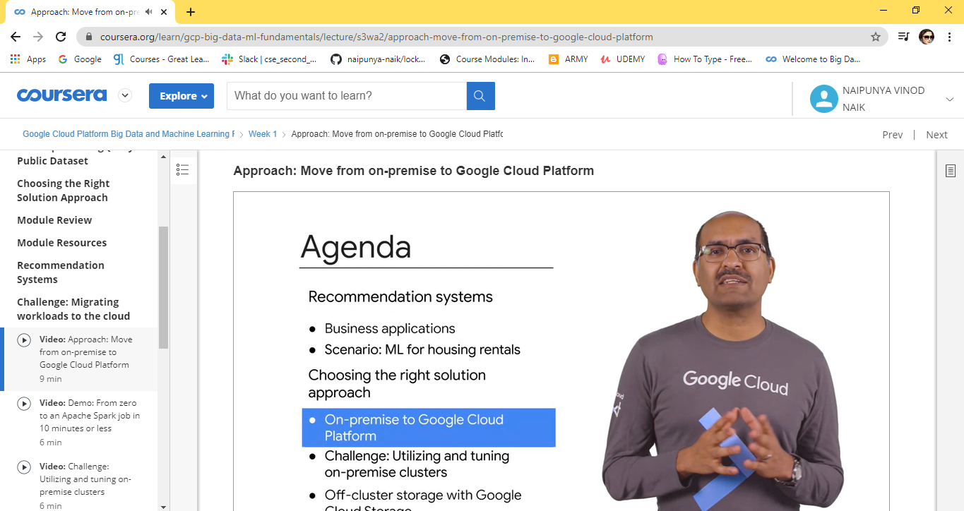

Coding Challenges Details: (Attach the snapshot and briefly write the report for the same).

PROBLEM STATEMENT:- Write a Java Program to find the duplicate characters in a string.

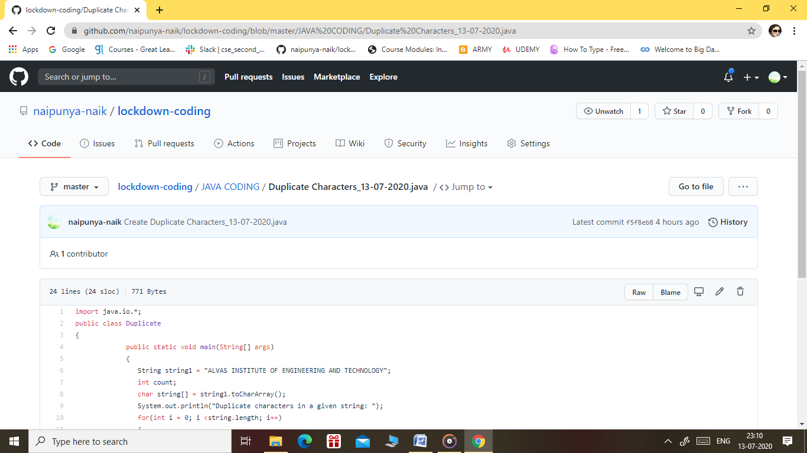

GITHUB REPOSITORY LINK:-

<https://github.com/naipunya-naik/lockdown-coding/blob/master/JAVA%20CODING/Duplicate%20Characters_13-07-2020.java>